**Java 2D Graphics Transformations Assignment**

**Student**: Patrick Walsh

**School**: University of Maryland Global Campus

**Course**: CMSC 325 6380

**Date**: 9/10/2021

**Professor**: Dr. Michael Elms

**Description**: Java program that creates a window and draws 5 images on the screen. Each image uses two or more colors and represents one of the 5 elements in traditional Chinese culture: fire, water, earth, metal, and wood. Each element is presented below:

**Fire Water Earth Metal Wood**



When launched, the program displays the images and performs several transformations to translate, rotate, and scale them. The transformations are as follows:

1. Translate -10 in X direction, +12 in Y direction.
2. Rotate 55 degrees counterclockwise.
3. Rotate 75 degrees clockwise.
4. Scale 3.0 times for X component, 1.5 times for Y component.

Below is each transformation when the program is launched:

**Initial launch**:

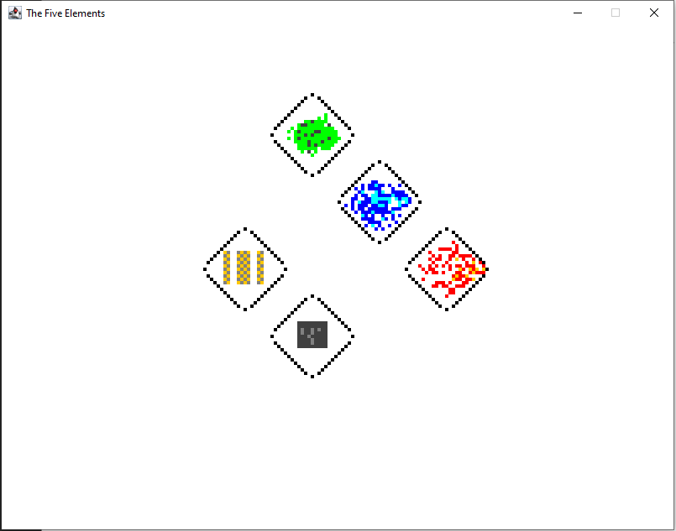

**Transform 1** (Translate -10 X, +12 Y):

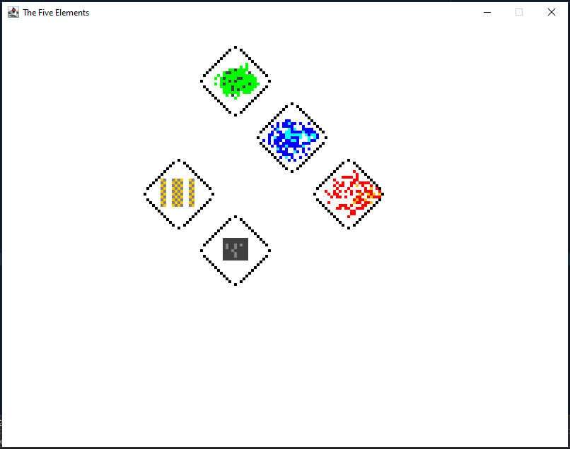

**Transform 2** (Rotate 55 degrees counterclockwise):

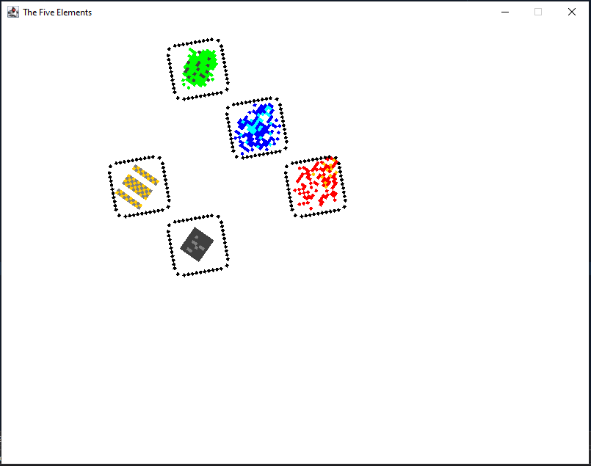

**Transform 3** (Rotate 75 degrees clockwise):

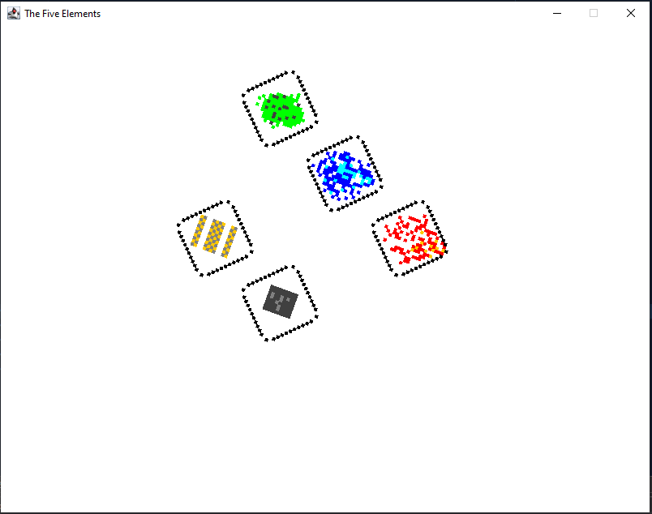

**Transform 4** (Scale 3.0 times for X component, 1.5 times for Y component):

